# Report 3: System Requirements Specifications (SRS)

## 3.1. User Requirement Specification

## 3.2. System Requirement Specification

### 3.2.1. External Interface Requirements

### 3.2.1.1. User Interfaces

### 3.2.1.1.1. Main Page

### 3.2.1.1.2. Login Screen

* For users that have account.
* Prompts the user to input their account information to login.
* Notifies the user if their information is invalid.

### 3.2.1.1.3. Register Screen

* For users that do not have account.
* Prompts the user to input required information to create a new account.
* Notifies the user if the input information is invalid.

### 3.2.1.1.4. Admin Page

* Show all subpages that the admin manages.
* Logout to exit admin page.

### 3.2.1.2. Hardware Interfaces

The **OMCS** is intended as a website runs well on all web browsers. At present, W.E.I.C does not have mobile version.

### 3.2.1.3. System Interfaces

### 3.2.1.4. Communications Protocol

### 3.2.2. Functional Requirements

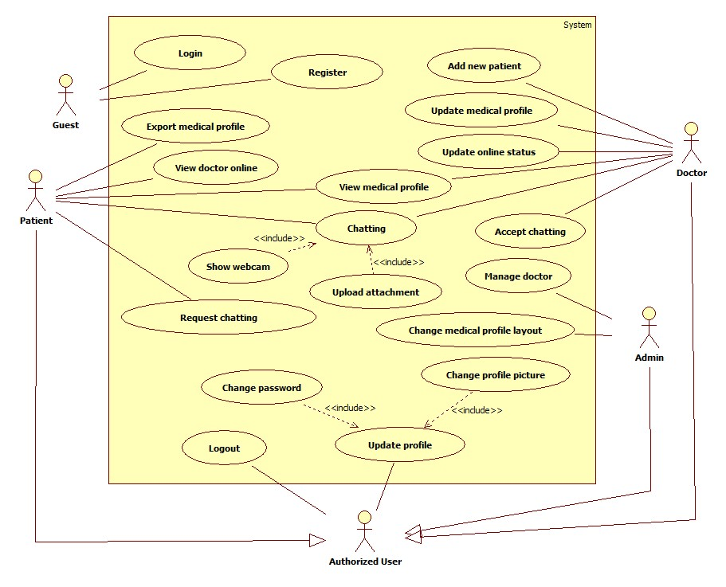

**Use Case Diagram**

### 3.2.2.1. Functional Requirement 1 - Login

### 3.2.2.1.1. Use Case-1 Diagram

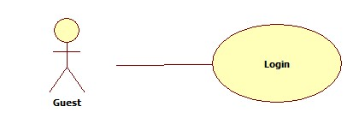

### 3.2.2.1.2. Use Case-1 Specification

|  |  |  |  |  |
| --- | --- | --- | --- | --- |
| **USE CASE - 1 SPECIFICATION** | | | | |
| **Use-case No.** | UC_001 | **Use-case Version** | | **1.0** |
| **Use-case Name** | Login | | | |
| **Author** | TinBN | | | |
| **Date** | 29/05/2014 | **Priority** | Normal | |
| **Actor:** Guest who already had an account created by doctor.  **Summary:** Login into system  **Goal:** Check user’s role to use system’s functions.  **Triggers:**Click on “Đăng nhập” to login  **Preconditions:**   * Page is loaded successfully. * Users are in “Homepage”page.   **Post-Conditions:**   * Success: member login successfully. * Failure: System displays error message. Content of error message will specify in Exception section.   **Main Success Scenario:**   |  |  |  | | --- | --- | --- | | Step | Actor Action | System Response | | 1 | Click “Đăngnhập” link on homepage |  | | 2 |  | Display a form and request to enter user’s information. | | 3 | Fill username and password. [Alternative1] |  | | 4 | Click “Đăngnhập”button. |  | | 5 |  | Validate username and password, redirect to home page, show message: “Xin chào [username] đã đăng nhập thành công”. |   **Alternative Scenario:** N/A  **Exception:**   |  |  |  | | --- | --- | --- | | No | Actor Action | System Response | | 1 | When user fills wrong username or password. | Display a hint message “Tên đăng nhập hoặc mật khẩu không đúng, xin thử lại". | | 2 | When network disconnected. | Display an informed message”Kết nối mạng bị lỗi.” | | 3 | Username or password is blank. | Show message: “Username hoặc password không đuợc để trống”. |   **Relationship:** N/A  **Business Rules:** After 5 times wrong, the system will lock account for 30 minutes | | | | |

### 3.2.2.2. Functional Requirement 2 - Register

### 3.2.2.2.1. Use Case-2 Diagram

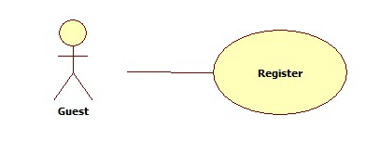

### 3.2.2.2.2. Use Case-2 Specification

|  |  |  |  |  |
| --- | --- | --- | --- | --- |
| **USE CASE - 2 SPECIFICATION** | | | | |
| **Use-case No.** | UC_002 | **Use-case Version** | | **1.0** |
| **Use-case Name** | Register | | | |
| **Author** | TinBN | | | |
| **Date** | 29/05/2014 | **Priority** | Normal | |
| **Actor:** Guest  **Summary:** User uses this function to register into system.  **Goal:** Help guest to create an account on website.  **Triggers:**Click on “Đăng ký” to register.  **Preconditions:**   * Page is loaded successfully * Register page will be shown   **Post-conditions:**   * Guest become member of website   **Main Success Scenario:**   |  |  |  | | --- | --- | --- | | Step | Actor Action | System Response | | 1 | Click on “Đăng ký” link on homepage |  | | 2 |  | Display Register page. | | 3 | Fill all mandatory fields |  | | 4 | Click on [Đồng ý] button |  | | 5 |  | Validate the inputted information and save to database. When it’s done show message ”Bạn đã đăng ký thành công” |   **Alternative Scenario:** N/A  **Exception:**   |  |  |  | | --- | --- | --- | | No | Actor Action | System Response | | 1 | “Tên đăng nhập” text-box is empty | Display message:”Bạn chưa điền tên thành viên. Xin vui lòng thử lại!” | | 2 | When user fills username is more than 15 characters or less than 8 characters | Display message “Tên đăng nhập phải từ 8 đến 15 ký tự. Xin vui lòng thử lại!” | | 3 | When user fills exist username | Display message “Tên đăng nhập bạn chọn đã được sử dụng, xin vui lòng thử tên khác” | | 4 | Mandatory field which have a mark ”*” is empty | Display message “Thông tin của bạn chưa đúng” doesn’t fill information has “*" | | 5 | When user fills password is more than 15 characters or less than 8 characters | Display message “Mật khẩu phải từ 8 đến 15 ký tự. Xin vui lòng thử lại!” |   **Relationship:** Create Request  **Business Rules:**   * All information need to fill correct * Users are in “Đăng ký” page | | | | |

### 3.2.2.3. Functional Requirement 3 - Export Medical Profile

### 3.2.2.3.1. Use Case-3 Diagram



### 3.2.2.3.2. Use Case-3 Specification

|  |  |  |  |  |
| --- | --- | --- | --- | --- |
| **USE CASE - 3 SPECIFICATION** | | | | |
| **Use-case No.** | UC_003 | **Use-case Version** | | **1.0** |
| **Use-case Name** | Export Medical Profile | | | |
| **Author** | DangTH | | | |
| **Date** | 29/05/2014 | **Priority** | Normal | |
| **Actor:** Patient  **Summary:** This use case is about exporting medical profile for a patient.  **Goal:** Patient can export a medical profile.  **Triggers:** Patient clicks “Xuất hồ sơ bệnh án**”** button on “Sơ lược về bệnh nhân” page.  **Preconditions:** User must log in with role “Patient”.  **Post-Conditions:** Export medical profile successfully.  **Main Success Scenario:**   |  |  |  | | --- | --- | --- | | Step | Actor Action | System Response | | 1 | User logins with role patient and clicks “Xuất hồ sơ bệnh án” button. |  | | 2 |  | Display “Chi tiết xuất**”** screen**.** This screen includes location, file type for user to choose easily. | | 3 | Choose file type and location to export. |  | | 4 | Clicks “Xuất”button. |  | | 5 |  | Display message “Xuất thành công” if medical profile is exported successfully. |   **Alternative Scenario:** N/A  **Exception:**   |  |  |  | | --- | --- | --- | | No | Actor Action | System Response | | 1 | User doesn’t choose location, file type. | Display message “Xuất thất bại”. | | 2 | Internet connection has problem | Display message “Đường truyền internet gặp trục trặc. Xin vui lòng thử lại!” |   **Relationship:** N/A  **Business Rules:** N/A | | | | |

### 3.2.2.4. Functional Requirement 4 - View Medical Profile

### 3.2.2.4.1. Use Case-4 Diagram



### 3.2.2.4.2. Use Case-4 Specification

|  |  |  |  |  |
| --- | --- | --- | --- | --- |
| **USE CASE - 4 SPECIFICATION** | | | | |
| **Use-case No.** | UC_004 | **Use-case Version** | | **1.0** |
| **Use-case Name** | View Medical Profile | | | |
| **Author** | DangTH | | | |
| **Date** | 29/05/2014 | **Priority** | Normal | |
| **Actor:** Patient  **Summary:** This use case is about Viewing medical profile for a patient.  **Goal:** Patient can view a medical profile.  **Triggers:** Patient clicks “Xem hồ sơ bệnh án**”** button on “Sơ lược về bệnh nhân” page.  **Preconditions:** User must log in with role “Patient”.  **Post-Conditions:** View medical profile successfully.  **Main Success Scenario:**   |  |  |  | | --- | --- | --- | | Step | Actor Action | System Response | | 1 | User logins with role patient and clicks “Xem hồ sơ bệnh án” button. |  | | 2 |  | Display “Hồ sơ bệnh án**”** Screen**.** This screen shows medical record of patient. |   **Alternative Scenario:** N/A  **Exception:**   |  |  |  | | --- | --- | --- | | No | Actor Action | System Response | | 1 | Internet connection has problem | Display message “Đường truyền internet gặp trục trặc. Xin vui lòng thử lại!” |   **Relationship:** N/A  **Business Rules:** N/A | | | | |

### 3.2.2.5. Functional Requirement 5 – Request Chatting

### 3.2.2.5.1. Use Case-5 Diagram



### 3.2.2.5.2. Use Case-5 Specification

|  |  |  |  |  |
| --- | --- | --- | --- | --- |
| **USE CASE - 5 SPECIFICATION** | | | | |
| **Use-case No.** | UC_005 | **Use-case Version** | | **1.0** |
| **Use-case Name** | Request chatting | | | |
| **Author** | DangTH | | | |
| **Date** | 29/05/2014 | **Priority** | Normal | |
| **Actor:** Patient  **Summary:** This use case is about Requesting chatting for a patient.  **Goal:** Patient can request chatting.  **Triggers:** Patient clicks “Chat**”** button on “Liên lạc với bác sĩ” page.  **Preconditions:** User must log in with role “Patient”.  **Post-Conditions:** Request chatting successfully.  **Main Success Scenario:**   |  |  |  | | --- | --- | --- | | Step | Actor Action | System Response | | 1 | User logins with role patient and clicks “Yêu cầu chat” button correspond with each doctor’s nick. |  | | 2 |  | Send request into doctor. | | 3 | doctor denies/accepts request |  | | 4 |  | Show message “Yêu cầu bị từ chối” for patient if doctor denies.  Show “Chat” Screen between patient and doctor if doctor accepts. |   **Alternative Scenario:** N/A  **Exception:**   |  |  |  | | --- | --- | --- | | No | Actor Action | System Response | | 1 | Internet connection has problem | Display message “Đường truyền internet gặp trục trặc. Xin vui lòng thử lại!” |   **Relationship:** N/A  **Business Rules:** N/A | | | | |

### 3.2.2.6. Functional Requirement 6 – Show Webcam

### 3.2.2.6.1. Use Case-6 Diagram



### 3.2.2.6.2. Use Case-6 Specification

|  |  |  |  |  |
| --- | --- | --- | --- | --- |
| **USE CASE - 6 SPECIFICATION** | | | | |
| **Use-case No.** | UC_006 | **Use-case Version** | | **1.0** |
| **Use-case Name** | Show Webcam | | | |
| **Author** | DangTH | | | |
| **Date** | 29/05/2014 | **Priority** | Normal | |
| **Actor:** Patient, Doctor  **Summary:** This use case is about Showing webcam when chatting.  **Goal:** User can request showing webcam.  **Triggers:** User clicks “Webcam**”** button on “chatting” window.  **Preconditions:** User must log in with role “Patient” or “Doctor”  **Post-Conditions:**   * Success: Show webcam successfully. * Failure: System displays error message. Content of error message will specify in Exception section.   **Main Success Scenario:**   |  |  |  | | --- | --- | --- | | Step | Actor Action | System Response | | 1 | User clicks “Webcam” button on chatting window. |  | | 2 |  | Send request into the opposite user. | | 3 | Opposite user denies/accepts request |  | | 4 |  | Show message “Yêu cầu bị từ chối” for user if the opposite user denies.  Show webcam of both users if the opposite user accepts. |   **Alternative Scenario:** N/A  **Exception:**   |  |  |  | | --- | --- | --- | | No | Actor Action | System Response | | 1 | Internet connection has problem | Display message “Đường truyền internet gặp trục trặc. Xin vui lòng thử lại!” | | 2 | User doesn’t have webcam | Display message “Không tìm thấy webcam từ máy của bạn, vui long kiểm tra lại”. |   **Relationship:** N/A  **Business Rules:** N/A | | | | |

### 3.2.2.7. Functional Requirement 7 – Upload Attachment

### 3.2.2.7.1. Use Case-7 Diagram



### 3.2.2.7.2. Use Case-7 Specification

|  |  |  |  |  |
| --- | --- | --- | --- | --- |
| **USE CASE - 7 SPECIFICATION** | | | | |
| **Use-case No.** | UC_007 | **Use-case Version** | | **1.0** |
| **Use-case Name** | Upload Attachment | | | |
| **Author** | DangTH | | | |
| **Date** | 29/05/2014 | **Priority** | Normal | |
| **Actor:** Patient, Doctor  **Summary:** This use case is about Uploading attachment for user when chatting.  **Goal:** User can upload attachment when chatting.  **Triggers:** User clicks “Gửi tập tin**”** button on “chatting”window.  **Preconditions:** User must log in with role “Patient” or “Doctor”.  **Post-Conditions:**   * Success: Upload attachment successfully. * Failure: System displays error message. Content of error message will specify in Exception section.   **Main Success Scenario:**   |  |  |  | | --- | --- | --- | | Step | Actor Action | System Response | | 1 | User clicks “Gửi tập tin” button on “chatting” windows. |  | | 2 |  | Show “Chọn tập tin để gửi” window. This window will help user access to the file that user want to attach. | | 3 | User chooses the file and clicks “Save” button. |  | | 4 |  | Upload file and display message “Đang tải lên ... Vui lòng đợi”.  When upload successfully, system will give a link to the opposite user for downloading the file. |   **Alternative Scenario:** N/A  **Exception:**   |  |  |  | | --- | --- | --- | | No | Actor Action | System Response | | 1 | File size is larger than specified file. | Display message “Tập tin lớn hơn quy định. Vui lòng chọn tập tin phù hợp với yêu cầu” | | 2 | Internet connection has problem | Display message “Đường truyền internet gặp trục trặc. Xin vui lòng thử lại!” |   **Relationship:** N/A  **Business Rules:** N/A | | | | |

### 3.2.2.8. Functional Requirement 8 – View Doctor Online

### 3.2.2.8.1. Use Case-8 Diagram



### 3.2.2.8.2. Use Case-8 Specification

|  |  |  |  |  |
| --- | --- | --- | --- | --- |
| **USE CASE - 8 SPECIFICATION** | | | | |
| **Use-case No.** | UC_008 | **Use-case Version** | | **1.0** |
| **Use-case Name** | Upload Attachment | | | |
| **Author** | DangTH | | | |
| **Date** | 29/05/2014 | **Priority** | Normal | |
| **Actor:** Patient  **Summary:** This use case is about viewing doctor online for a patient.  **Goal:** Patient can view doctor online.  **Triggers:** Patient goes to doctor list and online doctor will appear and have online status.  **Preconditions:** User must log in with role “Patient”.  **Post-Conditions:** Online doctors appear in the online list.  **Main Success Scenario:**   |  |  |  | | --- | --- | --- | | Step | Actor Action | System Response | | 1 | User logins with role patient and clicks “Xem danh sách các bác sĩ đang trực tuyến” link on “Danh sách bác sĩ” page. |  | | 2 |  | Show the list of online doctor and doctors will be grouped by speciality. |   **Alternative Scenario:** N/A  **Exception:**   |  |  |  | | --- | --- | --- | | No | Actor Action | System Response | | 1 | Database connection has problem | Display message:”Hệ thống gặp trục trặc. Xin vui lòng thử lại!” | | 2 | Internet connection has problem | Display message “Đường truyền internet gặp trục trặc. Xin vui lòng thử lại!” |   **Relationship:** N/A  **Business Rules:** N/A | | | | |

### 3.2.2.9. Functional Requirement 9 - Add new Patient

### 3.2.2.9.1. Use Case-9 Diagram

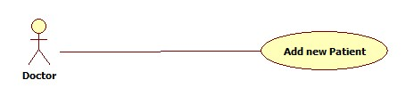

### 3.2.2.9.2. Use Case-9 Specification

|  |  |  |  |  |
| --- | --- | --- | --- | --- |
| **USE CASE - 9 SPECIFICATION** | | | | |
| **Use-case No.** | UC_009 | **Use-case Version** | | **1.0** |
| **Use-case Name** | Add new Patient | | | |
| **Author** | DanhTC | | | |
| **Date** | 30/05/2014 | **Priority** | Normal | |
| **Actor:** Doctor  **Summary:** This use case is doctor add a new patient.  **Goal:** Doctor can add a new patient.  **Triggers:** Doctor clicks “Add new Patient**”** button on **Doctor Profile** page.  **Preconditions:** User must be logged - in as “Doctor”.  **Post-Conditions:**   * If success: A new patient is created in the system. * If failure: The doctor is presented with an error message.   **Main Success Scenario:**   |  |  |  | | --- | --- | --- | | Step | Actor Action | System Response | | 1 | User logged – in as “Doctor” and clicks “Add new Patient” button on **Doctor Profile** page. |  | | 2 |  | Display “Add new patient” page with fields to add. | | 3 | Input suitable fields and click “Add new Patient” button. |  | | 4 |  | Validate input data.  Display message “Add new patient successful” and save data to database. |   **Alternative Scenario:** Exit criteria from main flow: 4 validate input data fails, display “Add new patient fail”.  **Exception:**   * When internet connection has problem, the system will ask user for trying again. * Identity Card has been existed.   **Relationship:** N/A  **Business Rules:** N/A | | | | |

### 3.2.2.10. Functional Requirement 10 – Update medical profile

### 3.2.2.10.1. Use Case-10 Diagram

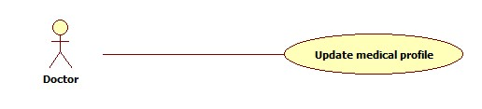

### 3.2.2.10.2. Use Case-10 Specification

|  |  |  |  |  |
| --- | --- | --- | --- | --- |
| **USE CASE - 10 SPECIFICATION** | | | | |
| **Use-case No.** | UC_010 | **Use-case Version** | | **1.0** |
| **Use-case Name** | Update medical profile | | | |
| **Author** | DanhTC | | | |
| **Date** | 30/05/2014 | **Priority** | Normal | |
| **Actor:** Doctor  **Summary:** This use case is doctor update medical profile.  **Goal:** Doctor can update medical profile.  **Triggers:** Doctor clicks “Update medical profile**”** button on **Doctor Profile** page.  **Preconditions:** User must be logged - in as “Doctor”.  **Post-Conditions:**   * If success: A new patient is updated in the system. * If failure: The doctor is presented with an error message.   **Main Success Scenario:**   |  |  |  | | --- | --- | --- | | Step | Actor Action | System Response | | 1 | User logged – in as “Doctor” and clicks “Update medical profile” button on **Doctor Profile** page. |  | | 2 |  | Display “Update medical profile” page with patient’s fields has been added to doctor can edit and update. | | 3 | Input suitable fields want to update and click “Update medical profile” button. |  | | 4 |  | Validate input data.  Display message “Update medical profile successful” and save data to database. |   **Alternative Scenario:** Exit criteria from main flow: 4 validate input data fails, display “Update medical profile fail”.  **Exception:**   * When internet connection has problem, the system will ask user for trying again.   **Relationship:** N/A  **Business Rules:** N/A | | | | |

### 3.2.2.11. Functional Requirement 11 – Update medical profile

### 3.2.2.11.1. Use Case-11 Diagram

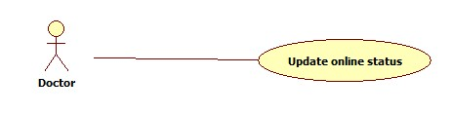

### 3.2.2.11.2. Use Case-11 Specification

|  |  |  |  |  |
| --- | --- | --- | --- | --- |
| **USE CASE - 11 SPECIFICATION** | | | | |
| **Use-case No.** | UC_011 | **Use-case Version** | | **1.0** |
| **Use-case Name** | Update online status | | | |
| **Author** | DanhTC | | | |
| **Date** | 30/05/2014 | **Priority** | Normal | |
| **Actor:** Doctor  **Summary:** This use case is doctor update online status.  **Goal:** Doctor can update online status.  **Triggers:** Doctor clicks “Update online status**”** button on **Doctor Profile** page.  **Preconditions:** User must be logged - in as “Doctor”.  **Post-Conditions:** Change status doctor  **Main Success Scenario:**   |  |  |  | | --- | --- | --- | | Step | Actor Action | System Response | | 1 | User logged – in as “Doctor” and clicks “Update online status” button on **Doctor Profile** page. |  | | 2 |  | Display drop down list of status such as: online, offline, busy to update online status. | | 3 | Choose online status. |  |   **Alternative Scenario:** N/A  **Exception:**   * When internet connection has problem, the system will ask user for trying again.   **Relationship:** N/A  **Business Rules:** N/A | | | | |

### 3.2.2.12. Functional Requirement 12 – Update medical profile

### 3.2.2.12.1. Use Case-12 Diagram

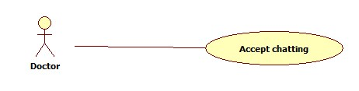

### 3.2.2.12.2. Use Case-12 Specification

|  |  |  |  |  |
| --- | --- | --- | --- | --- |
| **USE CASE - 12 SPECIFICATION** | | | | |
| **Use-case No.** | UC_012 | **Use-case Version** | | **1.0** |
| **Use-case Name** | Accept chatting | | | |
| **Author** | DanhTC | | | |
| **Date** | 30/05/2014 | **Priority** | Normal | |
| **Actor:** Doctor  **Summary:** This use case is doctor accept chatting.  **Goal:** Doctor can accept chatting to chat with patient.  **Triggers:** Doctor clicks “Accept chatting**”** button on **Doctor Profile** page.  **Preconditions:** User must be logged - in as “Doctor” and have request chatting.  **Post-Conditions:** Accept chatting with patient  **Main Success Scenario:**   |  |  |  | | --- | --- | --- | | Step | Actor Action | System Response | | 1 | User logged – in as “Doctor” and clicks “Accept chatting” button on **Doctor Profile** page. |  | | 2 |  | Display window chat to chat with patient request. |   **Alternative Scenario:** N/A  **Exception:**   * When internet connection has problem, the system will ask user for trying again.   **Relationship:** N/A  **Business Rules:** N/A | | | | |

### 3.2.2.13. Functional Requirement 13 – Add Doctor

### 3.2.2.13.1. Use Case-13 Diagram

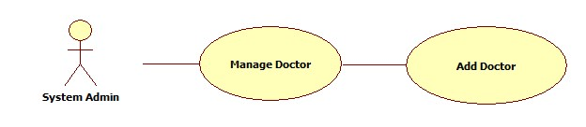

### 3.2.2.13.2. Use Case-13 Specification

|  |  |  |  |  |
| --- | --- | --- | --- | --- |
| **USE CASE - 13 SPECIFICATION** | | | | |
| **Use-case No.** | UC_013 | **Use-case Version** | | **1.0** |
| **Use-case Name** | Add Doctor | | | |
| **Author** | TinBN | | | |
| **Date** | 29/05/2014 | **Priority** | Normal | |
| **Actor:** Admin  **Summary:** This use case is about adding new doctor to system.  **Goal:** Help admin to add new doctor.  **Trigger:** Click “Thêm Bác Sĩ” on “management” page  **Precondition:**   * Page is loaded successfully. * Users have already logged in with role “admin”.   **Post-condition:**   * Succeed: New doctor added to system. * Failure: System displays error message. Content of error message will specify in Exception section.   **Main Success Scenario:**   |  |  |  | | --- | --- | --- | | Step | Actor Action | System Response | | 1 | Click on “Thêm Bác Sĩ” link on “managementpage” |  | | 2 |  | Display add doctor form | | 3 | Fill all mandatory fields |  | | 4 | Click on [Đồng ý] button |  | | 5 |  | Validate the inputted information and save to database. When it’s done show message ”Thêm bác sĩ thành công” |   **Alternative Scenario:** N/A  **Exception:**   |  |  |  | | --- | --- | --- | | No | Actor Action | System Response | | 1 | When network disconnected. | Display an informed message “Kết nối mạng bị lỗi.” | | 2 | When session timeout. | Display an informed message”Thời gian thực thi của bạn đã hết. Vui lòng đăng nhập lại.” |   **Relationship:** N/A  **Business Rules:** N/A | | | | |

### 3.2.2.14. Functional Requirement 14 – Remove Doctor

### 3.2.2.14.1. Use Case-14 Diagram

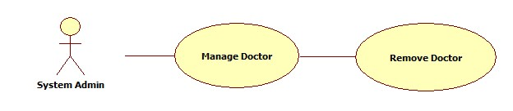

### 3.2.2.14.2. Use Case-14 Specification

|  |  |  |  |  |
| --- | --- | --- | --- | --- |
| **USE CASE - 14 SPECIFICATION** | | | | |
| **Use-case No.** | UC_014 | **Use-case Version** | | **1.0** |
| **Use-case Name** | Remove Doctor | | | |
| **Author** | TinBN | | | |
| **Date** | 29/05/2014 | **Priority** | Normal | |
| **Actor:** Admin  **Summary:** This use case is about change medical profile layout.  **Goal:** Help admin to change or update medical profile template.  **Trigger:** Select a doctor from doctor list in “managementpage” and click “Xóa bác sĩ”  **Precondition:**   * Page is loaded successfully. * Users have already logged in with role “admin”.   **Post-condition:**   * Succeed: Selected doctor removed from system. * Failure: System displays error message. Content of error message will specify in Exception section.   **Main Success Scenario:**   |  |  |  | | --- | --- | --- | | Step | Actor Action | System Response | | 1 | Click on a doctor in doctor list |  | | 2 | Click on “Xóa bác sĩ” |  | | 3 |  | Remove doctor from database. When it’s done show message ”Xóa bác sĩ thành công” |   **Alternative Scenario:** N/A  **Exception:**   |  |  |  | | --- | --- | --- | | No | Actor Action | System Response | | 1 | When network disconnected. | Display an informed message “Kết nối mạng bị lỗi.” | | 2 | When session timeout. | Display an informed message”Thời gian thực thi của bạn đã hết. Vui lòng đăng nhập lại.” |   **Relationship:** N/A  **Business Rules:** N/A | | | | |

### 3.2.2.15. Functional Requirement 15 – Change Medical Profile Layout

### 3.2.2.15.1. Use Case-15 Diagram

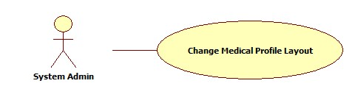

### 3.2.2.15.2. Use Case-15 Specification

|  |  |  |  |  |
| --- | --- | --- | --- | --- |
| **USE CASE - 15 SPECIFICATION** | | | | |
| **Use-case No.** | UC_015 | **Use-case Version** | | **1.0** |
| **Use-case Name** | Change Medical Profile Layout | | | |
| **Author** | TinBN | | | |
| **Date** | 29/05/2014 | **Priority** | Normal | |
| **Actor:** Admin  **Summary:** This use case is about change medical profile layout.  **Goal:** Help admin to change or update medical profile template.  **Trigger:** Click on “Thay đổi mẫu thông tin bệnh nhân” bệnh nhân on “managementpage”  **Precondition:**   * Page is loaded successfully. * Users have already logged in with role “admin”.   **Post-condition:**   * Succeed: Medical profile template updated. * Failure: System displays error message. Content of error message will specify in Exception section.   **Main Success Scenario:**   |  |  |  | | --- | --- | --- | | Step | Actor Action | System Response | | 1 |  |  | | 2 |  |  | | 3 |  |  |   **Alternative Scenario:** N/A  **Exception:**   |  |  |  | | --- | --- | --- | | No | Actor Action | System Response | | 1 | When network disconnected. | Display an informed message “Kết nối mạng bị lỗi.” | | 2 | When session timeout. | Display an informed message”Thời gian thực thi của bạn đã hết. Vui lòng đăng nhập lại.” |   **Relationship:** N/A  **Business Rules:** N/A | | | | |

### 3.2.2.16. Functional Requirement 16 – Change Picture Profile

### 3.2.2.16.1. Use Case-16 Diagram

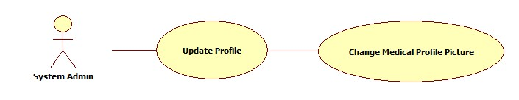

### 3.2.2.16.2. Use Case-16 Specification

|  |  |  |  |  |
| --- | --- | --- | --- | --- |
| **USE CASE - 16 SPECIFICATION** | | | | |
| **Use-case No.** | UC_016 | **Use-case Version** | | **1.0** |
| **Use-case Name** | Change Picture Profile | | | |
| **Author** | TinBN | | | |
| **Date** | 29/05/2014 | **Priority** | Normal | |
| **Actor:** Authenticated User: Admin, patient, doctor  **Summary:** This use case is about change medical profile picture  **Goal:** Help user to change their medical profile picture  **Trigger:** Click on profile picture in “profile” page and select “Thay đổi ảnh đại diện” to change medical profile picture.  **Precondition:**   * Page is loaded successfully. * Users have already logged in.   **Post-condition:**   * Succeed: User’s medical profile picture changed. * Failure: System displays error message. Content of error message will specify in Exception section.   **Main Success Scenario:**   |  |  |  | | --- | --- | --- | | Step | Actor Action | System Response | | 1 | Click on “Profile picture” link on profile page and select “Thay đổi ảnh đại diện”. [Alternative1] |  | | 2 |  | Display a “change profile” picture box. | | 3 | Select a template profile picture or upload owner’s picture. |  | | 4 | Click on “Đồng ý” button. |  | | 5 |  | Save to database. When it’s done show message ”Bạn đã thay đổi ảnh đại diện thành công” |   **Alternative Scenario:** N/A  **Exception:**   |  |  |  | | --- | --- | --- | | No | Actor Action | System Response | | 1 | When network disconnected. | Display an informed message “Kết nối mạng bị lỗi.” | | 2 | When session timeout. | Display an informed message”Thời gian thực thi của bạn đã hết. Vui lòng đăng nhập lại.” |   **Relationship:** N/A  **Business Rules:** N/A | | | | |

### 3.2.2.17. Functional Requirement 17 – Change Password

### 3.2.2.17.1. Use Case-17 Diagram

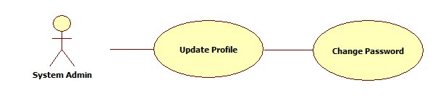

### 3.2.2.17.2. Use Case-17 Specification

|  |  |  |  |  |
| --- | --- | --- | --- | --- |
| **USE CASE - 17 SPECIFICATION** | | | | |
| **Use-case No.** | UC_017 | **Use-case Version** | | **1.0** |
| **Use-case Name** | Change Password | | | |
| **Author** | TinBN | | | |
| **Date** | 29/05/2014 | **Priority** | Normal | |
| **Actor:** Authenticated User: Admin, patient, doctor.  **Summary:** This usecase is about changing password for user.  **Goal:** User can change their password.  **Trigger:** Click on “Đổi mật khẩu” button in “profilepage” to change password.  **Precondition:**   * Page is loaded successfully. * Users have already logged in.   **Post-condition:**   * Succeed: User’s password changed. * Failure: System displays error message. Content of error message will specify in Exception section.   **Main Success Scenario:**   |  |  |  | | --- | --- | --- | | Step | Actor Action | System Response | | 1 | Click “Đổi mật khẩu” link on profile page. [Alternative1] |  | | 2 |  | Display a “change password” text-box. | | 3 | Fill all mandatory fields. |  | | 4 | Click on “Đồng ý” button. |  | | 5 |  | Validate the inputted information and save to database. When it’s done show message ”Bạn đã thay đổi mật khẩu thành công” |   **Alternative Scenario:** N/A  **Exception:**   |  |  |  | | --- | --- | --- | | No | Actor Action | System Response | | 1 | When network disconnected. | Display an informed message “Kết nối mạng bị lỗi.” | | 2 | When session timeout. | Display an informed message”Thời gian thực thi của bạn đã hết. Vui lòng đăng nhập lại.” |   **Relationship:** N/A  **Business Rules:** N/A | | | | |

### 3.2.2.18. Functional Requirement 18 – Logout

### 3.2.2.18.1. Use Case-18 Diagram

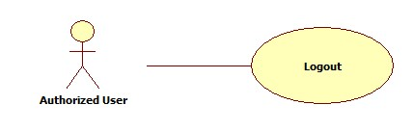

### 3.2.2.18.2. Use Case-18 Specification

|  |  |  |  |  |
| --- | --- | --- | --- | --- |
| **USE CASE - 18 SPECIFICATION** | | | | |
| **Use-case No.** | UC_018 | **Use-case Version** | | **1.0** |
| **Use-case Name** | Logout | | | |
| **Author** | TinBN | | | |
| **Date** | 29/05/2014 | **Priority** | Normal | |
| **Actor:** Authenticated User: Admin, patient, doctor  **Summary:** Log out system  **Goal:** Help user to log out their account.  **Triggers:** Click on “Đăng xuất” to log out  **Preconditions:**   * Page is loaded successfully. * Users have already logged in.   **Post-Conditions:**   * Success: users log out successfully. * Failure: System displays error message. Content of error message will specify in Exception section.   **Main Success Scenario:**   |  |  |  | | --- | --- | --- | | Step | Actor Action | System Response | | 1 | Click “Đăng xuất” link on main page. [Alternative1] |  | | 2 |  | Display a confirm box. | | 3 | Click “Có” button. [Alternative2] |  | | 4 |  | Logout user, redirect to Home page, logout successfully. |   **Alternative Scenario:** N/A  **Exception:**   |  |  |  | | --- | --- | --- | | No | Actor Action | System Response | | 1 | When network disconnected. | Display an informed message “Kết nối mạng bị lỗi.” | | 2 | When session timeout. | Display an informed message ”Thời gian thực thi của bạn đã hết. Vui lòng đăng nhập lại.” |   **Relationship:** N/A  **Business Rules:** N/A | | | | |